**FORM VALIDATION**

1. Required Validation

‘required’ attribute

1. Text length validation

minlength=”*integer*” the minimum number of characters we want to allow

maxlength=”*integer*” the maximum number of characters we want to allow

1. Number range validation

min=”*integer*” the minimum number we want to allow

max=”*integer*” the maximum number we want to allow

1. Pattern validation

pattern=”*regex*” to ensure data matches a particular pattern

It is good practice to use a ‘placeholder’ attribute to show users an example of the expected pattern they need to enter.

1. Styling validations

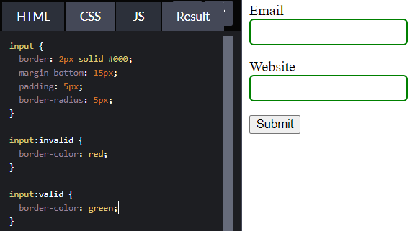Use the :valid & :invalid pseudo-classes